












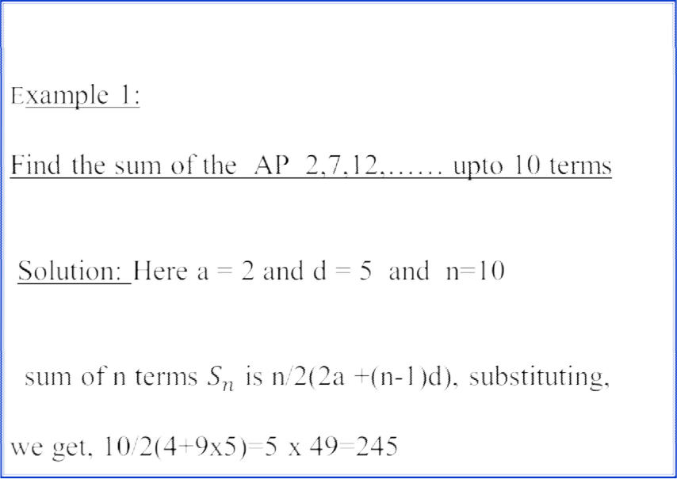


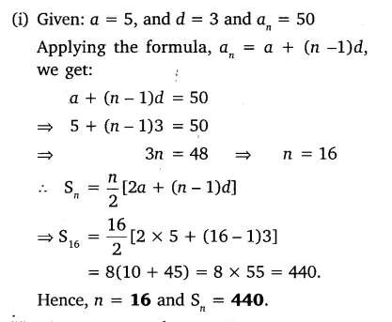

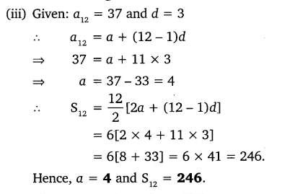
Example- 4;

How many terms of the following series – 12, -9, -6, -3,
. . . . . . . must be taken so that the sum may be 54? Solution:
The given series is – 12, -9, -6, -3, . . . . . . .
Sn = 54 , a = -12 , d = 3

54 = ( n /2) [ -24 + (n -1)3 ]
⇒ n2 -9n – 36 = 0
By factorizing the above equation we can get n values of 12 & -3
Here the value of n cannot be negative. So n = 12
Example – 5:

Find the sum of of first 200 terms of the following series 1 + 4 + 6 + 5 + 11 + 6 + 16 + 7 + . . . . . . . . . .

Solution:
The given series is
1 + 4 + 6 + 5 + 11 + 6 + 16 + 7 + . . . (200 terms
The above series treat every two consecutive terms as one.
i.e (1 + 4) +( 6 + 5) + (11 + 6) + (16 + 7) + . . . . . . . . . . ( 100
terms)
5 + 11 + 17 + 23 + . . . . . . . ( 100 terms )
Here a = 5 , d = 6 and n = 100

S100 = (100/2) [ (2 x 5) + (99 x 6)] = 30200

Example: 7
The first term of an arithmetic sequence is −1 and the fifteenth term is 27. Find the common difference and the sum of the first fifteen terms.
Solution:
The first term of an arithmetic sequence is −1 and the fifteenth term is 27. Find the common difference and the sum of the first fifteen terms.
a ₁ = − 1; a ₁₅ = 27;
a n = a 1 + (n − 1) · d
27= −1 + (15 − 1) d; 28 = 14d; d = 2
S= (−1 + 27) 15/2 = 195

Example: 8
Find the sum of the first fifteen numbers ending in 5.

Solution:

a₁= 5; d= 10 ; n= 15.

a₁₅= 5 + 14 ·10= 145

S15 = (5 + 145)· 15/2 = 1125
Example: 9

Find the angles of a convex quadrilateral, knowing they are in arithmetic sequence and d = 25º.

Solution:

The sum of the interior angles of a quadrilateral is 360º. 360= ( a₁ + a₄) · 4/2
a₄= a₁ + 3 · 25
360= ( a1 + a1 + 3 · 25) · 4/2
a1 = 105/2 = 52º 30' a2 = 77º 30'
a3 = 102º 30' a4 = 127º 30'
Problem 10:

The smaller leg of a right triangle is 8 cm in length. Calculate the other two knowing that the sides of the triangle form an arithmetic sequence.
a₂ = 8 + d; a₃ = 8 + 2d (8 + 2d)² = (8 + d)² + 64
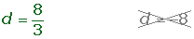

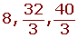

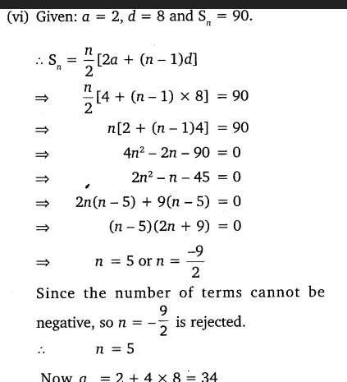

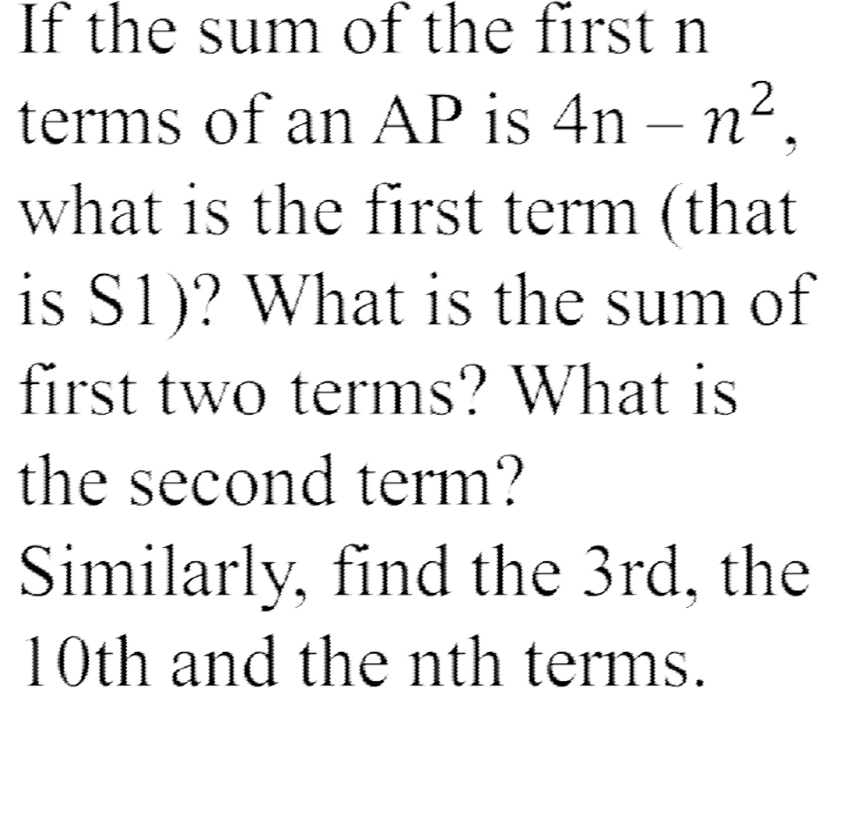

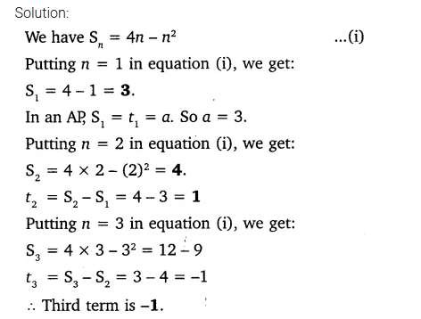

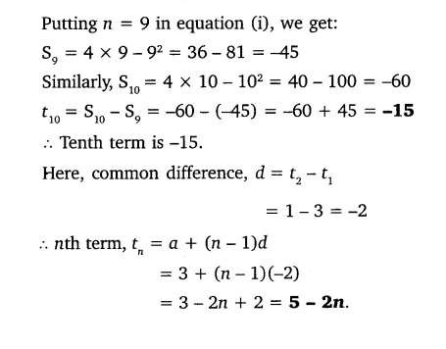

A contract on construction job specifies a penalty for delay of completion beyond a certain date as follows:
₹ 200 for the first day, ₹ 250 for the second day,
₹ 300 for the third day, etc. the penalty for each succeeding day being ₹ 50 more than for the preceding day. How much money the contractor has to pay as penalty, if he has delayed the work by 30 days?

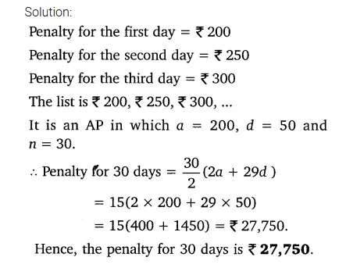

200 logs are stacked in the following manner 20 logs in the bottom row, 19 in the next row, 18 in the row next to it and so on (see Figure). In how many rows are the 200 logs placed and how many logs are in the top row?


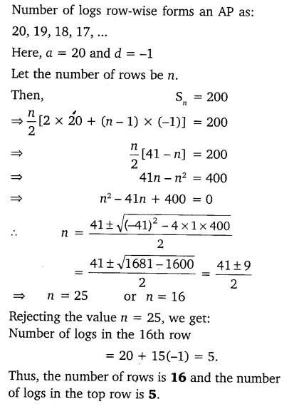

In a potato race, a bucket is placed at the starting point, which is 5 m from the first potato, and the other potatoes are placed 3 m apart in a straight line. There are ten potatoes in the line.A competitor starts from the bucket, picks up the nearest potato, runs back with it, drops it in the bucket, runs back to pick up the next potato, runs to the bucket to drop it in, and she continues in the same way until all the potatoes are in the bucket. What is the total distance the competitor has to run?

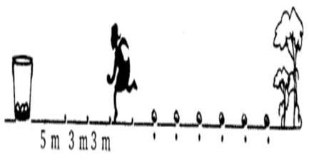

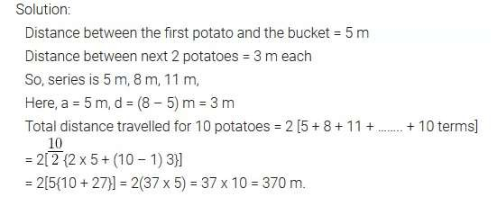


THANK YOU!!!!!!!

